Ruh.ai V1 Tenant Overlay Kit
AI BuildOps - GitHub + Linear + Slack + Sentry
Deployment-ready overlay for one software organization, one trust boundary, and an AI-product delivery conveyor

VERSION  0.1.0 | PACK REF  ai-buildops@1.0.0 | PRIMARY USE  Pilot + first production overlay | DATE  2026-03-08

Executive snapshot
This overlay kit binds the reusable AI BuildOps pack to a delivery stack where GitHub is the code and pull-request system of record, Linear is the planning system of record, Slack is the operator and approval surface, and Sentry is the normalized source for production incidents and regressions.
The overlay is designed for teams building AI products that already have modern engineering tools but still suffer from fragmented intake, incomplete specifications, inconsistent handoffs, manual release preparation, and slow incident learning loops.
The recommended first activation slice is intake-to-spec, spec-to-build orchestration, eval and release prep, and incident-to-regression learning.
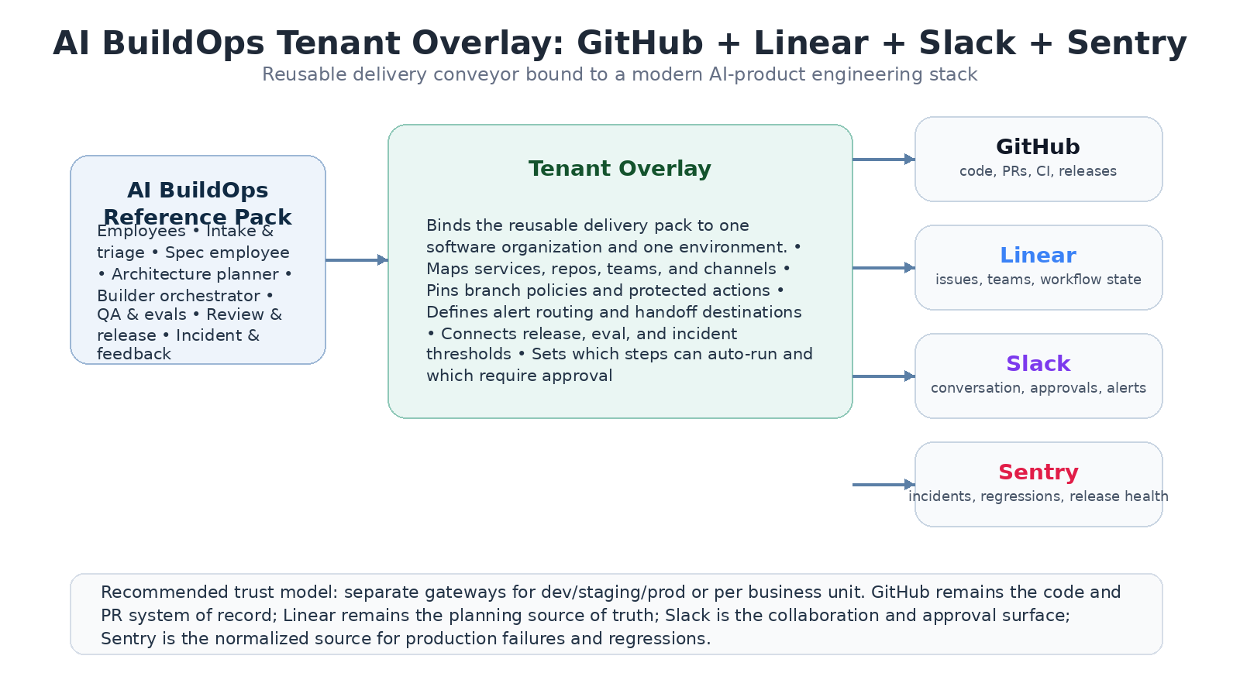
Figure 1. The overlay binds one reusable delivery pack to one engineering stack and one trust boundary.

1. Purpose, scope, and design choices
This document instantiates the AI BuildOps reference pack as a concrete tenant overlay. It specifies how canonical delivery objects map to GitHub, Linear, Slack, and Sentry; which employees are activated; what permissions and approvals apply; what rollout order is recommended; and how a design-partner deployment should be judged before production promotion.
- Keep GitHub as the source of truth for repositories, branches, pull requests, CI status, and releases.
- Keep Linear as the source of truth for issue ownership, planning state, and team routing.
- Use Slack for operator interaction, approvals, digests, and workflow visibility.
- Use Sentry as the normalized production-signal and regression source for post-release learning.
Out of scope in this overlay
Automatic merge to protected branches, autonomous production deployment, or any hidden bypass of existing branch-protection and release controls.
Replacing GitHub, Linear, Slack, or Sentry. The overlay orchestrates around those systems; it does not supersede them.

2. Stack assumptions and tenant prerequisites
The overlay assumes the engineering organization already operates with a reasonably stable repo, planning, and alerting structure. Ruh.ai should remove coordination tax, not compensate for total process absence.
Area | Minimum requirement | Why it matters
GitHub | Organization-level app install, repository list, branch protection already defined | Builder and review workflows need stable repos and PR rules.
Linear | Teams, workflow states, and project taxonomy in active use | Intake and spec handoffs need a clean planning backbone.
Slack | Engineering channels plus a dedicated approvals / alerts surface | Humans need a reliable place to supervise the conveyor.
Sentry | Project-level alerting and release associations in use | Incident learning depends on a trustworthy production signal source.
Service catalog | Named mapping of service -> repo -> team -> on-call group | The overlay routes work by service boundary, not by guesswork.

3. Overlay topology and trust-boundary model
Apply the overlay at the environment boundary first, then parameterize by service. The recommended pattern is one gateway per environment or business-unit trust boundary, with one workspace per service or delivery domain. That keeps repository context, credentials, and incident history from bleeding across unrelated teams.
- Tenant level: engineering-wide policies, connector installations, default evaluation profiles, and role groups.
- Environment level: dev, staging, production, or regulated/trusted segments with separate runtime credentials and deployment rules.
- Service level: repo mapping, Linear team, Slack channel, Sentry project, and approval roles.
- Workspace level: implementation context, generated plans, temporary artifacts, and runtime telemetry for one service boundary.
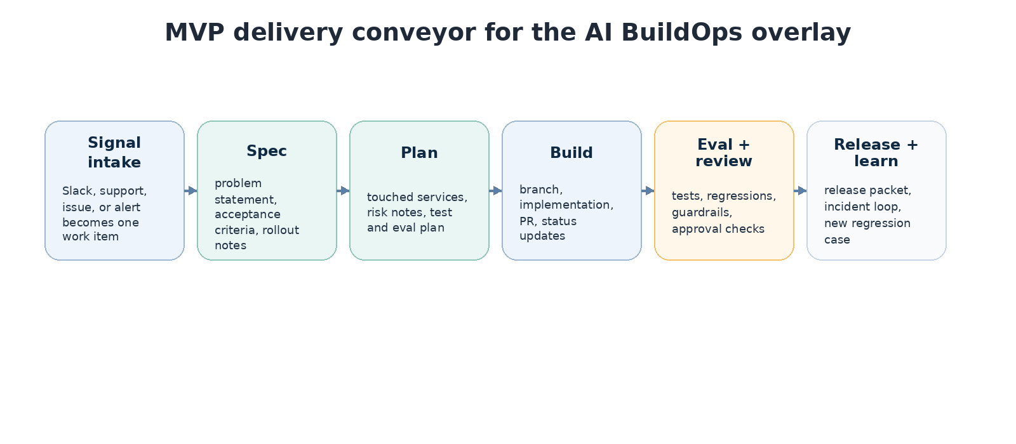
Figure 2. MVP delivery conveyor recommended for the first AI BuildOps overlay rollout.

4. Canonical object mapping
The pack stays horizontal by using canonical delivery objects. Only connectors should understand vendor-specific field names and payload shapes.
Canonical object | Primary source | Secondary source | Notes
WorkItem | Linear issue | Slack or Sentry signal reference | Planning ownership remains in Linear.
SpecArtifact | Ruh.ai artifact | Linked back to Linear issue | The artifact is the auditable planning payload.
CodeChange | GitHub branch / pull request | Linear issue link | Official code state stays in GitHub.
EvalRun | Ruh.ai run artifact | GitHub CI status + Sentry baseline | Eval gate results must be replayable.
ReleasePacket | GitHub release draft / artifact | Slack summary link | Release employee prepares, humans approve.
Incident | Sentry issue / alert | Slack alert thread | Sentry is the primary production-signal source.
RegressionCase | Ruh.ai eval asset | Linked incident / customer transcript | Production failures should feed new regression coverage.

5. Employee activation and permission envelope
The overlay should turn on employees one lane at a time and keep each one inside an explicit permission envelope. This is what makes the digital conveyor governed instead of chaotic.
Employee | Primary actions | Auto allowed | Approval required
Intake & triage | Normalize signals, de-duplicate, create work items | Create Linear issues and Slack summaries | Cross-team escalation outside mapped channels
Spec employee | Draft problem statement, criteria, rollout notes | Create or update structured spec artifact | Major scope change comments back to customer-facing threads
Architecture planner | Map touched services, risks, and test plan | Internal plan artifacts | None by default
Builder orchestrator | Create branch, draft code changes, open PR | Branch creation and PR open | Merge to protected branch or write secrets
QA & evals | Run tests, eval suites, compare baselines | Execute configured eval profiles | Override failed release gate
Review & release | Prepare release packet and docs updates | Internal release draft and changelog | Production deployment or final merge
Incident & feedback | Draft RCA, open follow-ups, create regression cases | Internal incident summary and new eval stub | External incident communication

6. Workflow activation plan
Do not activate the full conveyor on day one. Start with the narrowest slice that crosses the planning, code, and evaluation systems while leaving production control in human hands.
Workflow | Trigger | System of record | Primary metric
Intake -> spec | Slack request, support signal, or incident-linked issue | Linear + Ruh.ai spec artifact | Time from signal to ready-for-build work item
Spec -> build | Approved spec artifact | GitHub PR + Linear state | Spec-to-PR cycle time
Eval + release prep | Ready-for-review PR or release candidate | GitHub CI / release draft + Ruh.ai eval artifact | Gate pass rate and release prep time
Incident -> regression loop | Sentry issue or release regression | Sentry + Ruh.ai regression case | Time from incident to new regression coverage
Recommended pilot order
Week 1-2: intake, work normalization, and spec drafting only, with no builder permissions.
Week 3-4: enable builder orchestration for branch + PR creation in one non-critical service.
Week 5-6: add QA/evals and release packet generation behind explicit approval gates.
Week 7-8: add incident-to-regression loop using Sentry for one production service.

7. Connector profile and secrets inventory
Connector | Required access | Secret reference pattern | Health check
GitHub | Repo read/write for configured automation actions, PR metadata, CI status | secretref://connectors/github/* | List repos + create test branch in sandbox repo
Linear | Issue create/update, team and workflow read | secretref://connectors/linear/* | Read team map + create dry-run issue
Slack | Post messages, receive app mentions/events, create approval prompts | secretref://connectors/slack/* | Post test approval card and receipt
Sentry | Read issues, releases, alert metadata; optional annotations | secretref://connectors/sentry/* | List projects + fetch recent issue
Ruh runtime | Bundle apply, task execution, telemetry upload | secretref://runtime/* | Adapter heartbeat + bundle checksum verification
The overlay should never receive raw credentials in source-controlled files. All tokens and app secrets are injected via the platform secrets broker and referenced only by stable secret IDs.

8. Policy and approval overlay
Build automation becomes dangerous the moment it can silently merge, deploy, or communicate externally. The overlay therefore makes protected actions explicit and records why any gate was overridden.
Risk tier | Examples | Default policy | Approver
Low | Issue creation, spec draft, branch creation, internal digest | Auto allowed | None
Medium | Open PR, update release draft, create regression case in shared repo | Approval required or auto-allowed by service policy | Repo owner or release lead
High | Merge protected branch, deploy production, external incident message | Human only or approval required | Release manager / on-call lead / service owner
- No production deployment action should execute unless the overlay can prove the required eval profile passed and the named approver accepted the action.
- Any missing service mapping, unknown repo, or ambiguous incident ownership should block automation and route to manual triage.
- Every gate override must capture the approver, reason code, and linked work item or incident.

9. Notification, routing, and record ownership rules
Artifact / event | Primary destination | Owner of record
New work item | Linear issue + Slack summary | Linear
Spec artifact | Ruh.ai artifact + link posted in Slack | Ruh.ai artifact linked to Linear
Pull request | GitHub PR + Slack state message | GitHub
Eval summary | Ruh.ai eval artifact + GitHub status context | Ruh.ai eval artifact
Release packet | GitHub release draft + Slack approval prompt | GitHub release draft
Incident summary | Slack alert thread + linked follow-up tasks | Sentry issue + Ruh.ai RCA artifact
Slack is the conversation surface, not the canonical record. The overlay should always post links back to GitHub, Linear, Sentry, or stored Ruh.ai artifacts rather than treating chat messages as the source of truth.

10. Pilot acceptance gates and success metrics
Gate | Target before go-live
Connector auth | All four external connectors pass least-privilege review and health checks.
Routing quality | At least 95% of pilot signals route to the correct service/team in replay.
Eval discipline | 100% of release-candidate runs execute the required eval profile.
Protected-action compliance | No merge/deploy action occurs without the required approval record.
Cycle-time impact | Pilot shows measurable reduction in signal-to-spec or spec-to-PR time.
Recommended pilot KPIs
Signal-to-spec turnaround time
Spec-to-PR cycle time
Eval pass rate before release
Incident-to-regression-case turnaround time
Hours saved per engineering manager or tech lead per week

11. Example overlay excerpt
The full starter file is provided separately with this kit. The excerpt below shows the intended structure and the major fields platform and solution engineers are expected to fill.
kind: tenantOverlay
apiVersion: ruh.ai/v1alpha1
metadata:
overlayId: ai-buildops.github-linear-slack-sentry
packRef: ai-buildops@1.0.0
displayName: GitHub + Linear + Slack + Sentry overlay
owner: platform-solutions
environmentClass: production
version: 0.1.0
trustBoundary:
key: product-prod-core
runtimeProfile: prod
gateway:
mode: dedicated
workspaceStrategy: service-per-workspace
sandbox:
mode: non-main
scope: agent
services:
catalog:
- key: api
repo: github:acme/api
linearTeam: CORE
slackChannel: '#api-buildops'
sentryProject: api-prod
- key: web
repo: github:acme/web
linearTeam: APP
slackChannel: '#web-buildops'
sentryProject: web-prod
connectors:
github:
enabled: true
installationRef: secretref://connectors/github/app-prod
org: acme
protectedBranchPolicyRef: main-release-guardrails
linear:
enabled: true
installationRef: secretref://connectors/linear/app-prod
teamMap:
CORE: core-platform
APP: app-experience
slack:
enabled: true
installationRef: secretref://connectors/slack/app-prod
approvalChannel: '#eng-approvals'
alertChannel: '#eng-alerts'
sentry:
enabled: true
installationRef: secretref://connectors/sentry/app-prod

12. Day-2 operations and change control
- Treat overlay changes like product changes: stage them, test them, and promote them through a controlled environment sequence.
- Keep service mappings versioned. Do not silently repoint one overlay to different repos or teams without an audit trail.
- Rotate app credentials on a regular schedule and verify health checks immediately after rotation.
- Escaped failures should become new regression cases or policy rules before the next overlay release.

Appendix A. Source assumptions
This overlay kit assumes OpenClaw is used as a trust-bounded runtime plane with isolated agents, workspaces, routing bindings, AgentSkills-compatible skill folders, configurable hooks/cron automation, and optional sandboxing. The overlay design also assumes the documented security posture of one trusted operator boundary per gateway, which is why production deployments should separate customers and environments at the gateway layer.
- [R1] Agents - OpenClaw (isolated agents, workspaces, routing).
- [R2] Skills - OpenClaw (AgentSkills-compatible skill folders and precedence).
- [R3] Hooks - OpenClaw (event-driven automations discovered from directories).
- [R4] Cron Jobs - OpenClaw (persistent gateway scheduler).
- [R5] Security - OpenClaw (one trusted operator boundary per gateway).
- [R6] Agent Workspace - OpenClaw (workspace as default cwd; sandbox recommended for isolation).

